Linux Operating system

Linux:
- Linux is a free and Open-source operating system with high security. Linux is multiuser based OS.

Operating system:
An Operating System (OS) is a software that acts as an interface between computer hardware components and the user.
Every computer system must have at least one operating system to run other programs. Applications like Browsers, MS Office, Notepad Games, etc., need some environment to run and perform its tasks.

Linux OS Distributions:
- RedHat
- Ubuntu
- Debian
- Centos
- Fedora
- OpenSUSE
- Kali Linux
- Amazon Linux
- Rocky Linux

ARCHITECTURE:

KERNEL:
- manages the Hardware Components. CPU, memory, and peripheral devices. The kernel is the lowest level of the OS.
- It is the core or the heart of the operating system. It's the central part that manages and facilitates communication between the computer's hardware and software.

DAEMONS: Manages are background services (printing, sound, scheduling, etc.) that either start up during boot or after you log into the desktop.

SHELL:
- Manages are background services (printing, sound, scheduling, etc.) that either start up during boot or after you log into the desktop. A shell that allows users to interact with the operating system. There are two types of shells.
. Command Line Interface (CLI): Executes the command provided by user given in the form command and display the output in terminal.
. Executes the process provided by user in graphical way and output is displayed in the graphical window.
COMMAND:
- It is an instruction/request given to the operating system by a user.
- It tells computer to perform a particular task.
TERMINAL:
- It is a text-based interface that allows you to interact with the operating system by typing commands.
- It's a way for you to communicate with the Linux machines.

- In Linux we have different types of commands
- SYSTEM COMMANDS
- HARDWARE COMMANDS
- FILE COMMANDS
- PERMISSION COMMANDS
- USER COMMANDS
- SEARCH COMMANDS
- NETWORKING COMMANDS
- These commands are used in Linux operating system to perform different actions.

Linux commands:

touch command: used to create a file.
ls command: used to check the list of files.
whoami command: used to check the which directory.
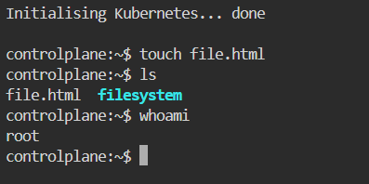
.
vi command: This command directly creates and open the file.
But, in this file we cannot write anything directly. So, there are some shortcuts.
Enter ‘I’ in keyboard to insert the text.
Enter ‘Esc’ button to exit from insert mode.
Enter ‘: wq’ for save and exit.
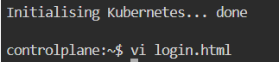
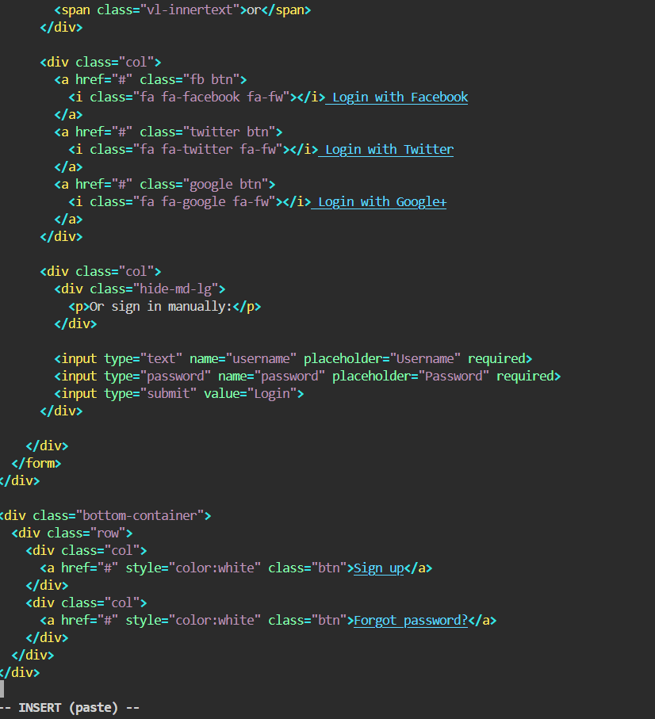
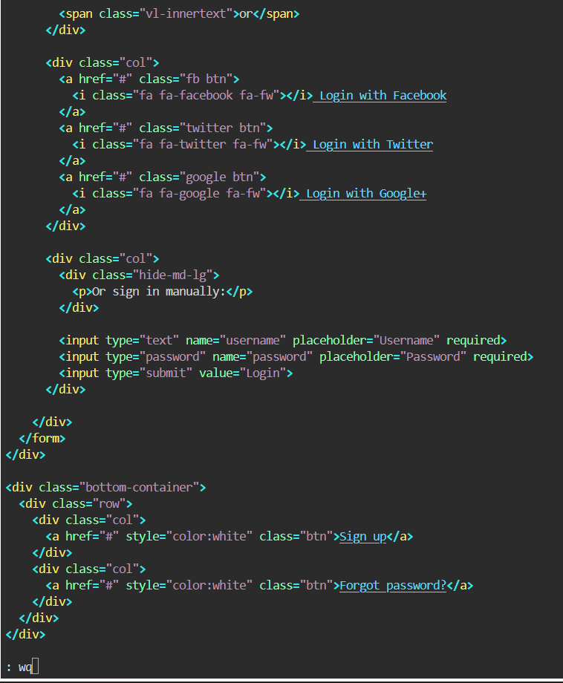
cat command: It is used to view the information that already exists in file.
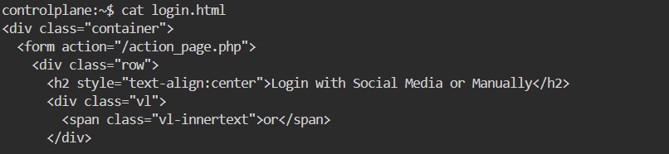

nano command: This command is for we can directly insert the information without any shortcut (like ‘I’ in keyboard).
But there are some shortcuts to save the file.
Enter ‘ctrl+x’ in keyboard to save options.
Enter ‘ctrl+y’ in keyboard to select yes and then ‘Enter’ button to exit.
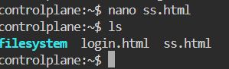
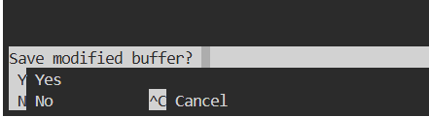

rm command: It is used to remove only one file at once.
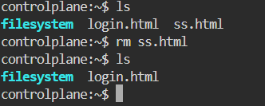

mkdir command: To create the new directory.
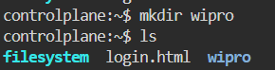
To move file to created directory “ mv <filename> <directoryname>” To bring back file from directory to root user “ mv <filename> ..”
cd command: To go to the root directory.
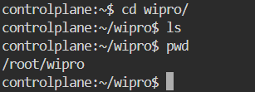

pwd command: used to check the which directory we are in present.

cd .. command: used to go back to the main directory.
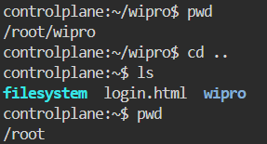

mv command: we use this command in two cases.
Case I: To change the name of the file.
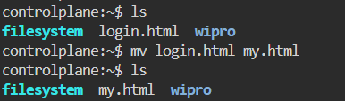
Case II: to move the file.
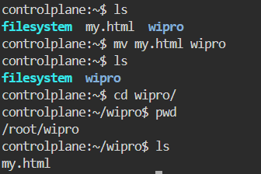
rmdir command: to remove the empty directory only.
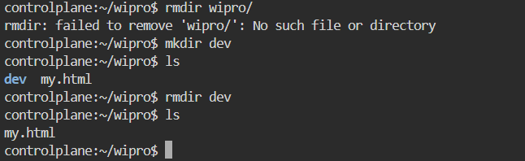

rm -rf command: used to remove the directory.
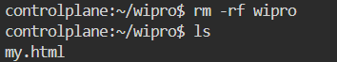

wget command: used to install any application via link.
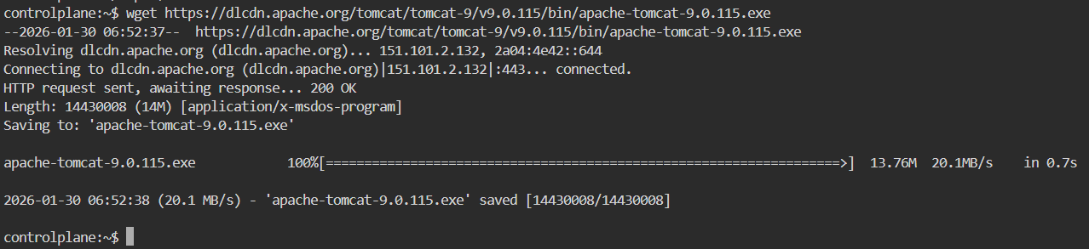

ping command: used to diagnoses network issues and confirms if a server is online or a network path is active.
To exit from this, use “ctrl+z”.
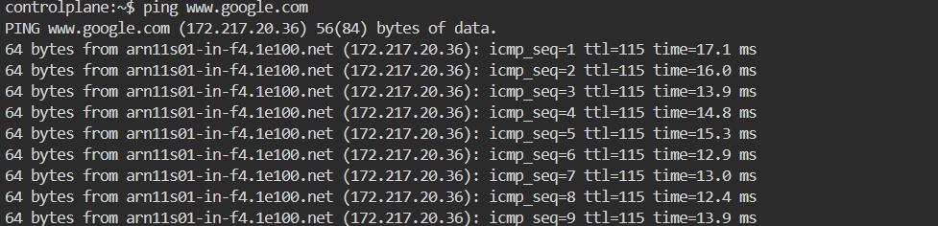

history command: to see all used commands in that editor.
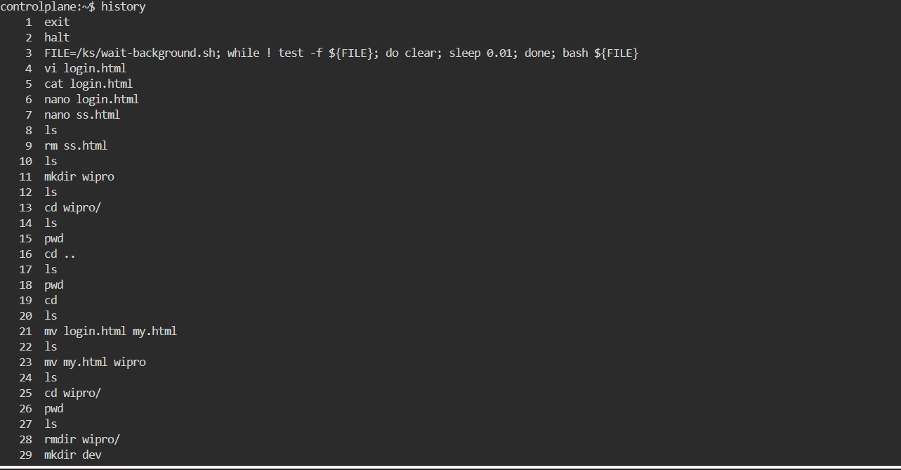
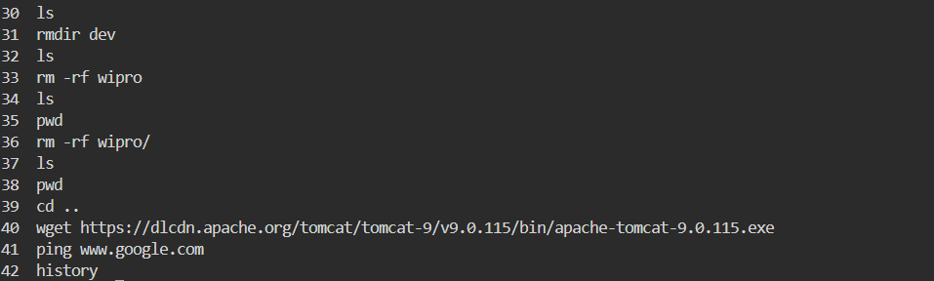

- Every file has 3 type permissions

1. User level
2. Group level
3. Other level

Permission types

R -> read permission
W -> write permission
X - > executable permission

1. Chmod: change permissions (read, write and execute)
2. Chown: change ownership (user and group)

R -> 4
W -> 2
X -> 1
- These numbers are important for numeric mode

ls -l command: It is used for to check which permission type is the file.

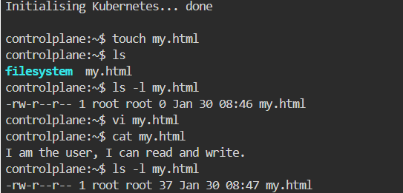

chmod command: To change permissions.

- There are two ways to change the file names using chmod

1. Symbolic mode (easy for beginners)

Syntax: chmod who operator permission file

Chmod: command
Who: user or group or other
Operators: +, -
Permission: r, w, x
file: file name
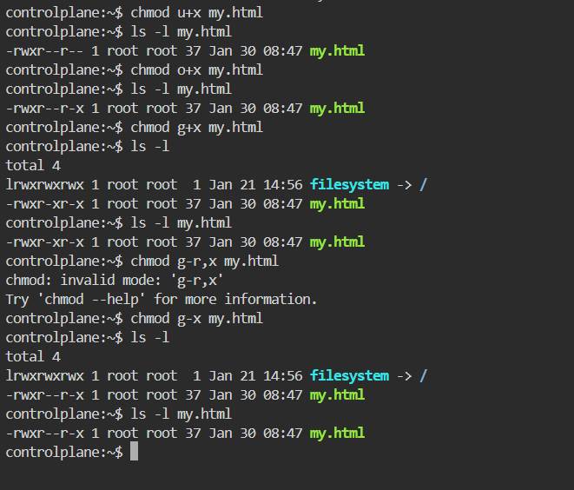

2. Numeric mode (most important for devops)

- Each permission has number value

R -> 4
W -> 2
X -> 1

- We must add numbers depends on permission
User: r+w+x -> 4+2+1 = 7
User2: rw- -> 4+2 = 6
Group: --x -> 1 = 1
Others: -w- -> 2 = 2

Syntax: Chmod rwx filename
Chmod 700 filename

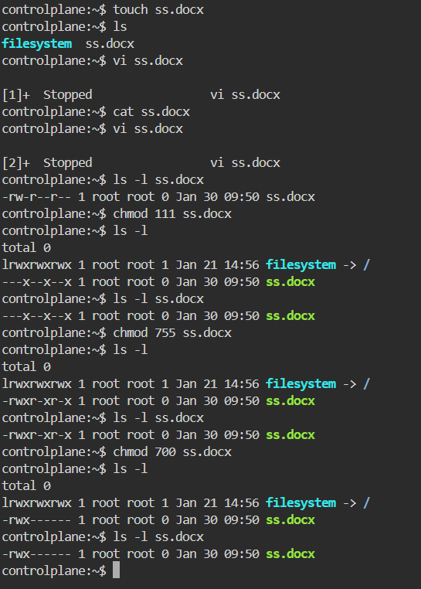

How to create users:

Method 1: Sudo useradd <username> (without password)
Here we see the user created:
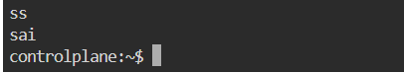

Method 2: Sudo adduser <username> (with password and userdetails)
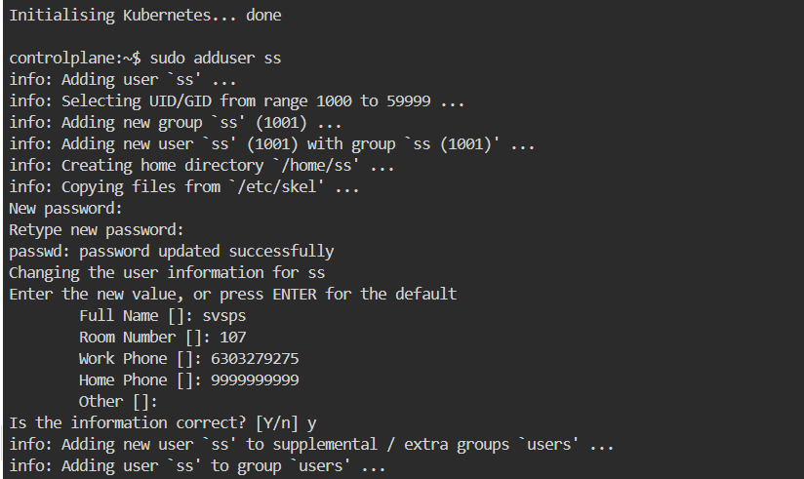

To login in the created user the command is “su - <username>”
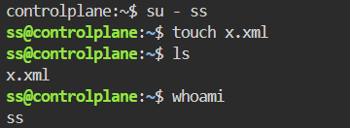

To logout from the user the command is “exit”
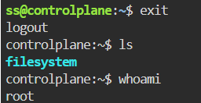

To check all users the command is “cat /etc/passwd”

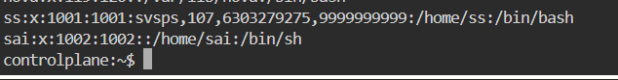

To see only usernames (not like above one), the command is “-d: -f1 /etc/passwd”

To delete the user “sudo deluser <username>”
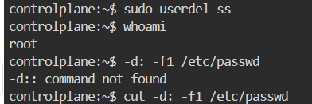
User deleted:
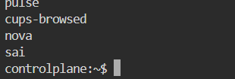

SYSTEM COMMANDS:

- uname: used to get type of OS
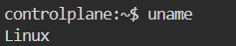
- uname -r: used to get kernel version of our OS
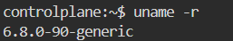
- uname -a: used to get full info about OS

- clear: this command is used to clear the clear (or) you can use ctrl + l as a short cut
- uptime: used to get since how long our system is in running state
- uptime -p: this will give only time
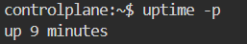
- hostname: used to get private dns name of our system
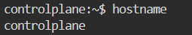
- hostname -i: used to get private Ip of our system
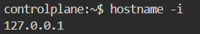
- hostnamectl set-hostname “<newname>”: used to change hostname
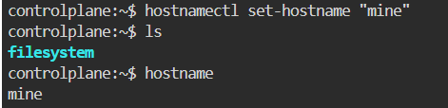
- ip addr: used to get private IP
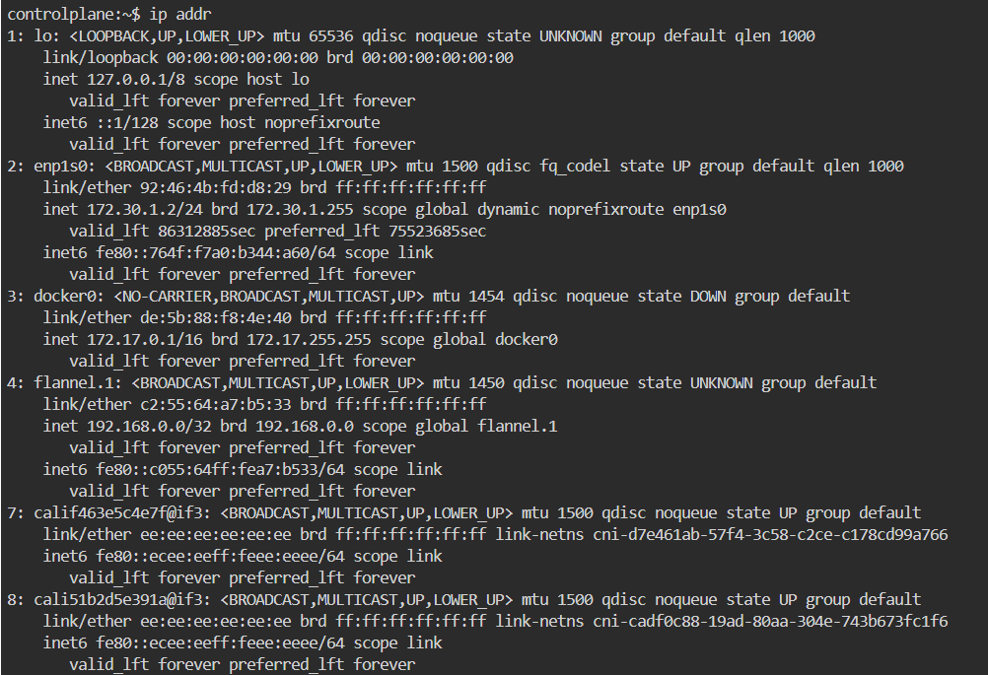
- ip route: used to get private IP
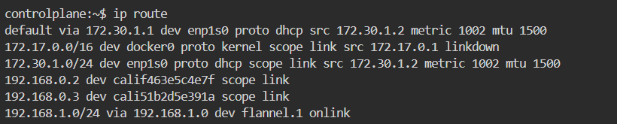

- ifconfig: used to get private IP
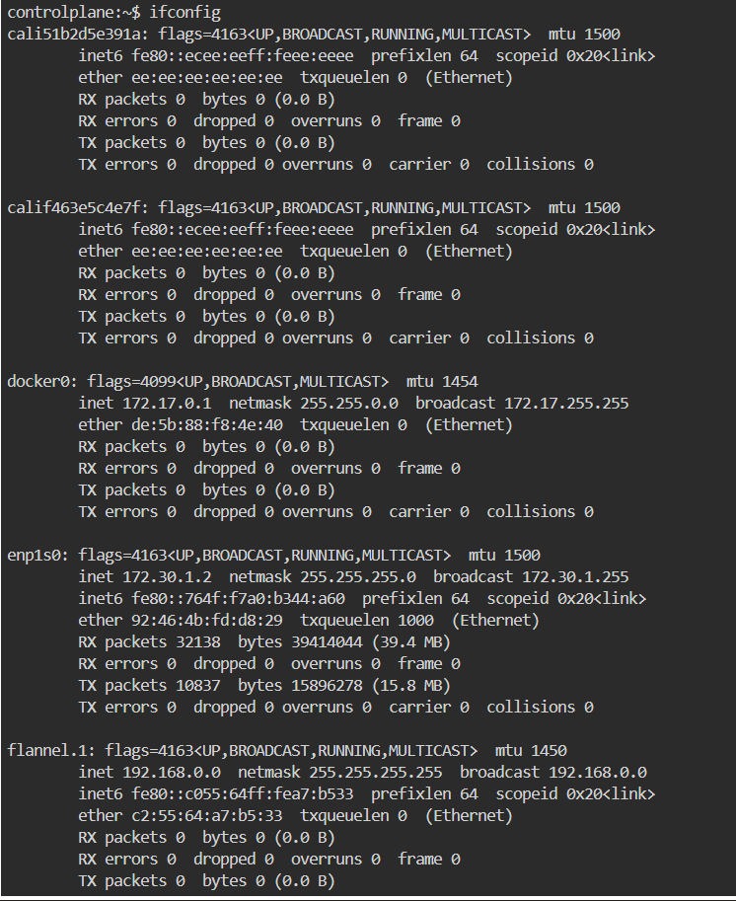
- date: to get todays date
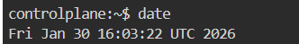
- timedatectl: used to get time zones
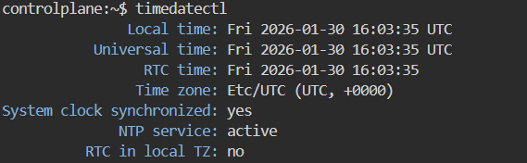
- timedatectl set-timezone Asia/Kolkata: used to change Timezone to IST

- who: used to see how many users have been logging into your system
- whoami: used to see the current user.
- ps: used to see the running processors in system
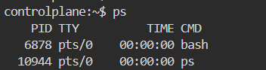
- kill -9 PID: used to kill a processor

- date +”%d”: Prints Day of the month (01-31)
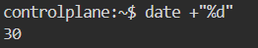
- date +”%m”: Prints the month of the year 01-12
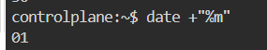
- date +”%y”: Prints only the last two digits of Year
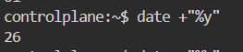
- date +”%H”: Prints the hour 00-23
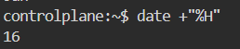
- date +”%M”: Prints the Minute of the hour 00-59
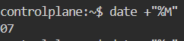
- date +”%S”: Prints the current seconds count in the minute (00-60)
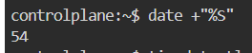
- date +"%D": Prints Date in MM/DD/YY
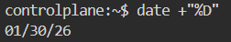
- date +”%F”: Prints only the Full date as YYYY-MM-DD
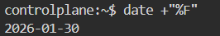
- date +”%A”: Prints the Day of the Week Saturday-Sunday
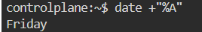
- date +”%B”: Prints the month between January-December
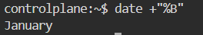

HARDWARE COMMANDS:
- lscpu (or) cat /proc/cpuinfo: Displays information about the CPU architecture
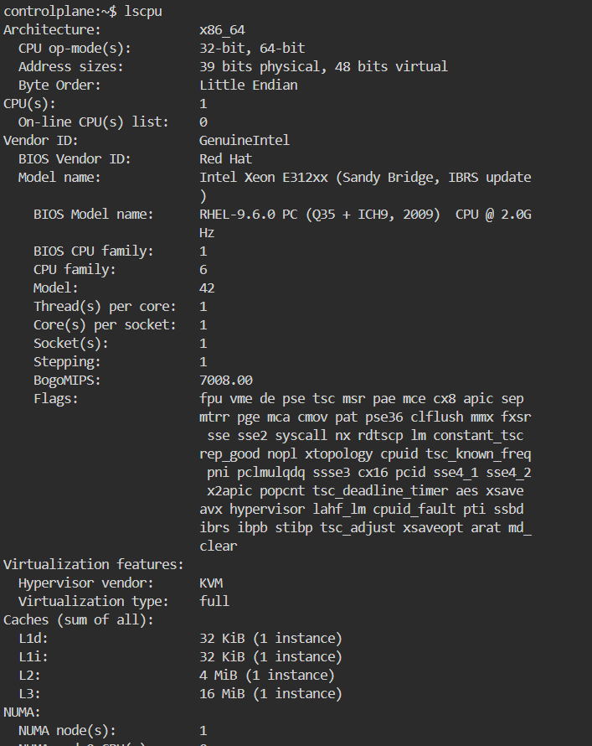
- lsblk -a: Lists the information about all the block devices attached to the system
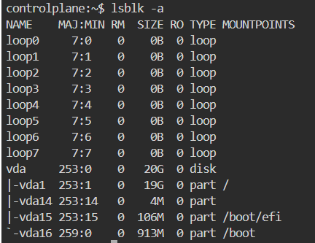
- free (or) cat /proc/meminfo: Displays system memory (RAM) details in KB
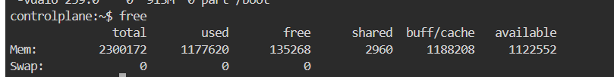

- free -m: Displays system memory (RAM) details in MB
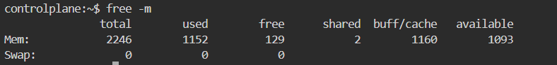
- df -h: Report file system disk space usage in human readable languages
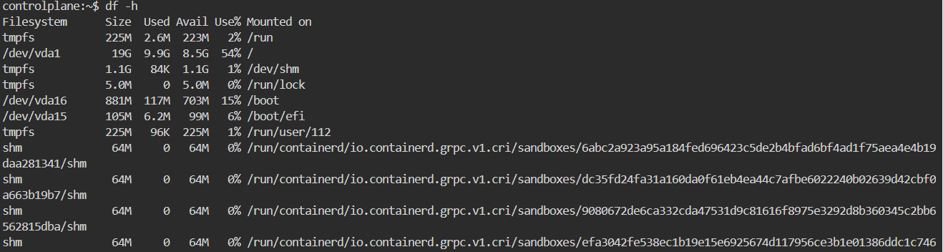

GREP (Global Regular Expression Print):
It is used to search for a word in a file
SYNTAX: grep “word” filename
- grep “word” filename: used to search for a word in a file
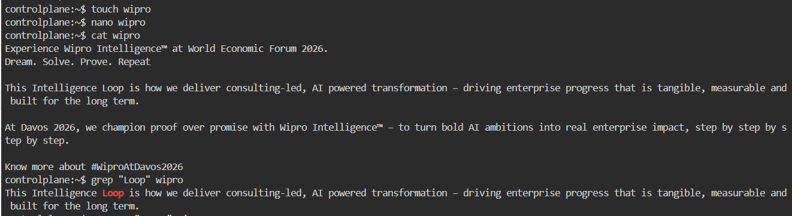
- grep -n “word” filename: it prints the data along with line numbers
- grep -c “word” filename: it prints no of occurrences of a word
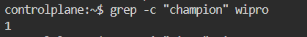
- grep -i “word” filename: used to search for a case-sensitive

